DNA-origami in Boston
Impression of a NBS internship by Sjors Wijnands

For six months I worked as a student researcher in the group of William Shih at the Wyss Institute in Boston, USA. This institute was founded in 2009 at Harvard University with the financial support of Hansjörg Wyss and its mission is to develop biologically inspired materials and devices to solve critical medical and environmental problems. Therefore, the institute has tight collaborations with several renowned local universities, hospitals and institutes like Harvard Medical School and the Dana Farber Cancer Institute (DFCI).
The group of prof. William Shih is specialized in DNA-origami which is a technique that uses DNA as a building block to construct DNA-nanostructures. Short staple-strands are designed to fold a long scaffold-strand in a desired 2D or 3D shape. This provides great control over the size and shape of these structures and the opportunity to decorate them with molecules that can be functionalized with a DNA-strand.
A general understanding of the design process, purification and characterization of a variety of DNA-structures is gained and research is now proceeding to investigating the potential of these structures as a tool for biomedical applications. One of these applications is the role as an adjuvant for the targeting of the human immune system as is investigated by dr. Maartje Bastings. Stimulation and control over the immune response is currently a very interesting topic in cancer treatment and research is performed on various targeting and stimulatory methods. Due to their regulatory role, dendritic cells (DCs) are a specifically interesting cellular target.
During my internship I worked on the design and functionalization of 3D DNA-origami structures which can be used to construct an adjuvant for the targeting and controlled activation of DCs (Fig. 1). To target the adjuvant to DCs, antibodies functionalized with DNA-strands are positioned on the outer surface of the DNA-structure. For the controlled activation of DCs, immunogenic agents are loaded on the inner surface of the adjuvant. In this case, ovalbumin antigens and the CpG sequence were functionalized with DNA-handles for the incorporation in the adjuvant. With the controlled delivery of these agents, the direction of the DC maturation and the subsequent instigation of immunological pathways can be controlled and directed against specific cell types like tumor cells. In the final month of my internship, I got the opportunity to take part in the first DC activation experiments where ovalbumin antigens were delivered using this DNA-origami structure. The fluorescently labeled origami structure and antigens were clearly taken up by the DCs and, after a while, the DNA was secreted from the cells whereas the antigens remained in the cells. These were the first promising results for the development of a highly modular and tightly controlled adjuvant for the activation of DCs.
My time in Boston was not only unforgettable due to these great results but also due to the inspiring people I worked with, the highly interesting research that is performed at the Wyss institute and last, but definitely not least, the city itself!
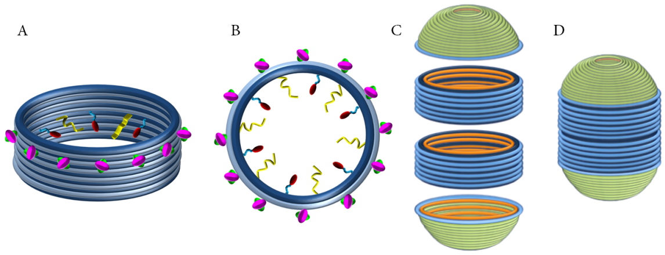
Figure 1. A,B: side and top-view of a circular DNA-origami structure (blue) functionalized with targeting antibodies (pink and green), antigens (red) and CpG sequence (yellow). C,D: The fully assembled pill-shaped DNA-origami adjuvant consists of 4 parts which protects its cargo.

