Internship Experience Report (Nora Baart Stichting)

Eline Sijbesma
Master Biomedical Engineering
Division Molecular Bioengineering & Molecular Imaging
Track Chemical Biology

Internship March – August 2015
“Exploring the potential of disulfide tethering to identify small-molecule stabilizers of 14-3-3 protein-protein interactions”
Division of Pharmaceutical Chemistry
Small Molecule Discovery Centre (SMDC) / University of California San Francisco (UCSF)
San Francisco, CA, United States of America

Before you start an (unpaid) internship in the USA you have to arrange your J-1 visa. This takes a lot of time, mostly because the university has to collect all the right documents (proof of insurance, university enrollment, financial status…) to complete your application after which you can make an appointment at the consulate and actually obtain a visa. I started the application process mid October 2014 and received my visa mid February 2015.

That was only the beginning – the real thing was still to get started. San Francisco is an incredibly expensive town to live in. Also, people are searching for rooms all the time and very last-minute. I did not want to rent anything that I did not see before so I sent out some responses on craiglist, booked a hostel for the first 4 nights and decided to start my real search after I got there. In the end I found a room via via on facebook. I arrived in SF on Wednesday, met with the landlord and roommates on Thursday, moved in on Saturday and started my internship the following Monday.

My project was a collaboration between my supervisor at TU/e and the group at UCSF. I worked in the small molecule discovery centre which is specialized in the early stage of drug discovery and development of new screening techniques. UCSF is a very inspiring environment. During my stay I performed multiple screens of a library containing about 1500 small molecules on several protein targets the group at TU/e is working on. I learned new techniques and approaches in the field of high-throughput screening and drug discovery.

Outside of the lab I had plenty of options to explore. Americans are very friendly and welcoming. San Francisco is a highly varied city with all kinds of people from all over the world. From little shops in Chinatown to hip coffee and brunch places in the Castro, bars and beergardens in the Mission and picnics in the enormous golden gate park, this great city has it all. The people and the atmosphere in this vibrant city are really amazing. To get the real American vibe I went to a Warriors (basketball) game and a few Giants (baseball) games!

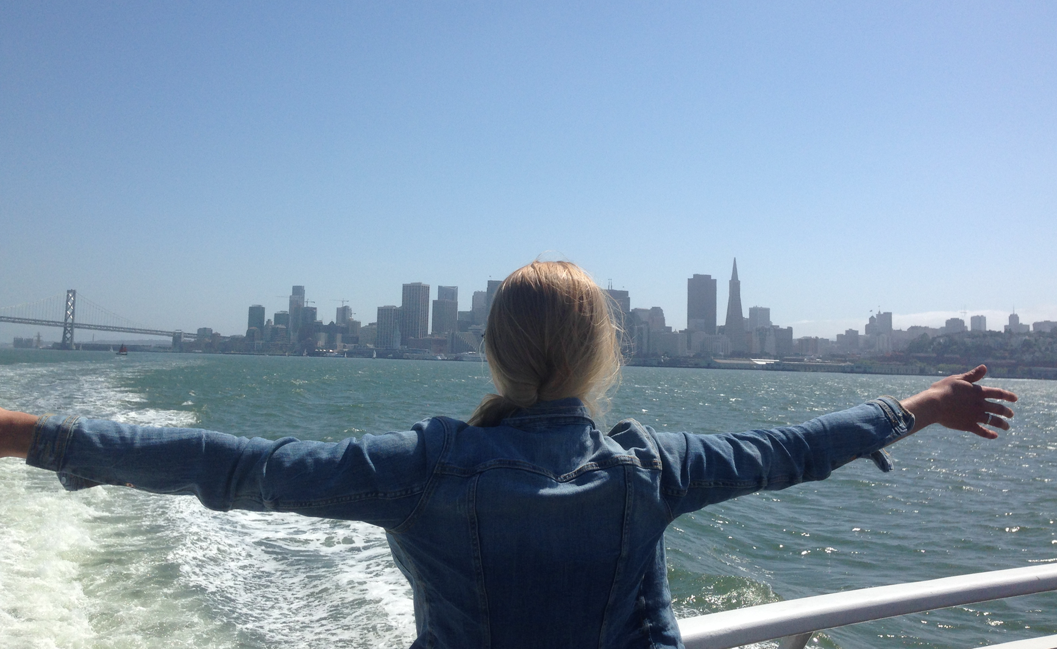
Evenings and weekends are easily filled in the Bay Area. Enough things to do and see and the weather is good almost all year round. The nature in California is beautiful and you only have to drive out of the city to explore. We went up to some hot springs in the mountains North of SF and drove back via Napa Valley where they make amazing wines. The memorial day weekend we went up to Lake Tahoe. Berkeley is just on the other side of the bay and well worth a visit. Backpacking in Big Sur was a great experience. After the internship period I went on a roadtrip for 3 weeks to visit Yosemite, Las Vegas, Zion and Bryce national park, Grand Canyon, San Diego, LA and much more in between. America is so beautiful. Just rent a car and bring a tent and you are good to go.

Overall, very inspiring and exciting research, amazing city and beautiful country. Definitely an experience never to forget and in my opinion essential in the development to become an independent researcher. This really convinced me to continue in this field and also made me realize there still is much more out there to go and explore!

