For my Master’s program, I conducted an eight month internship abroad at the University of California, Berkeley. I was part of the Hockemeyer group at the department Molecular and Cell Biology. Under supervision of Dr. Hockemeyer, a PhD candidate and a Postdoc of the group, I designed, optimized and performed a large-scale screen to study the molecular silencing mechanism of the protein human telomerase reverse transcriptase (hTERT). When designing a large-scale screen, you have to think about many details, carefully think of every step and adjust the screen based on preliminary results. I gained a lot of energy from this challenging project. The PhD candidate and Postdoc supervised me on a daily basis and helped me to improve my research skills. Moreover, the group leader Dr. Hockemeyer was really involved and enthusiastic. During weekly meetings and whenever he walked by my desk, he would give me input on my project. All researchers in the group were very talented and motivated each other in performing high quality research. Every week, we had a group meeting, in which we would discuss a recently published paper or project(s) of a lab member. Within this inspiring environment, I had the chance to learn many valuable lessons that will be useful in my further career.
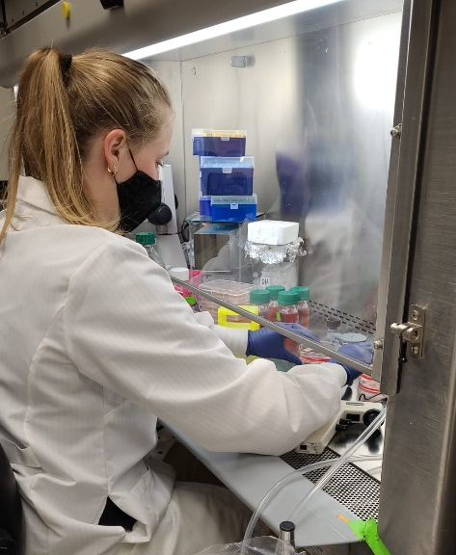
Berkeley is a real American college town, which made it easier to meet new people. I got the opportunity to get the full American experience with football games, baseball games, Halloween, Thanksgiving, dead week and spring break. The sun is always shining in the Bay area, which allowed me to plan small trips to San Francisco, the beach, the hills and even the dessert. It was a wonderful experience that I will take with me forever. Going to UC Berkeley was one of the best decisions I have ever made. I had the best time both inside and outside the lab. I have learned a lot about myself and what I consider important in research and a research group. Thanks to the NBS Travel Grant for Internships, I was able to perform this internship abroad and therefore, NBS contributed to an unforgettable experience.

