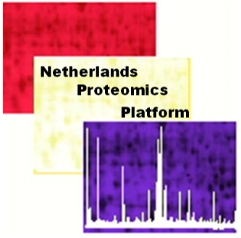
Draft Program
18th Annual Meeting of the Netherlands Proteomics Platform,
11 jan 2019 De Driehoek, Utrecht (www.indedriehoek.nl | near Utrecht CS)

“Subcellular Proteomics and Proteomics of Cellular Subsets”

9.00- 9.30 Registration and coffee
9.30- 9.45 Welcome + announcements (Connie Jimenez, steering committee NPP)

9.45- 10.45 KEYNOTE Deciphering chromatin biology using integrative omics approaches Michiel Vermeulen, Radboud University

10.45- 11.10 Regulatory T cell identity issues solved by mass spectrometry
Derk Amsen, Sanquin

11.10- 11.35 Synaptic protein complexes unraveled through cross-linking coupled to MS Miguel Gonzalez, VU (provisional title)

11.35- 12.00 Proteome insights of DNA damage-induced replication stress
Jurgen Marteijn, Erasmus MC (provisional title)

12.00- 13.30---------------------LUNCH (till 13.10) + 4x Vendor pitches ---------------------------------

13.30- 13.55 Urinary exosome proteomics in the diagnosis of cancer
Irene Bijnsdorp, Amsterdam UMC

13.55- 14.20 Advances in phosphoproteomics Celine Mulder (Utrecht University) (provisional title)

14.20- 14.45 Sample Preparation Bias in Mass Spectrometry-Based Proteomics
Frank Klont, RUG

14.45- 15.10 Proteomic dissection of Alzheimers’ Disease
David Hondius, Amsterdam UMC

15.10- 15.40-------------------------------------------TEA BREAK -----------------------------------------------

15.40- 16.05 Cleaving like a Pro: functional and structural characterization of bacterial Pro-Pro endopeptidases (PPEPs) Paul Hensbergen, LUMC

16.05- 17.00 KEYNOTE Phosphoproteomics to identify druggable kinase targets in cancer Jesper Olsen, University of Copenhagen

17.00- 18.00---------------------------------------------DRINKS---------------------------------------------------

This NPP event is sponsored by:
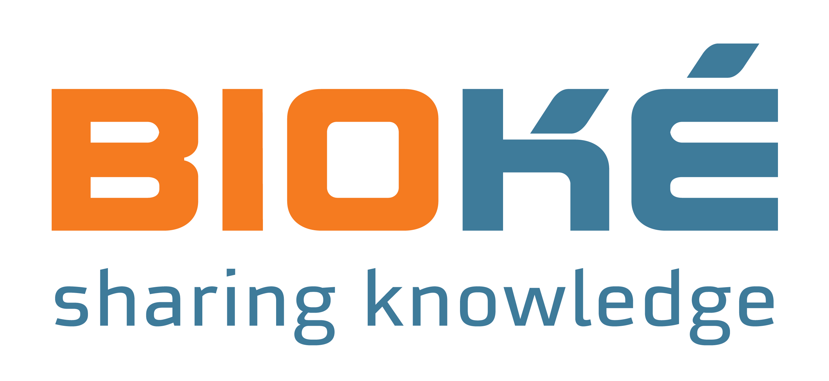

To register, please send an email to NetherlandsProteomicsPlatform@gmail.com;

Thanks to our sponsors we can offer the meeting free of charge, yet we do encourage you to become member of the NVBMB via https://nvbmb.kncv.nl/membership .

