My experience in Stockholm

Thanks to the Nora Baart Stichting, I had the opportunity to do my 8-month master thesis/internship at the Karolinska Institutet in Stockholm. In the group of Matti Sällberg, I focused on the development and in vivo testing of an mRNA-based immunotherapy for chronic hepatitis B/D virus. By switching a previously developed plasmid DNA vaccine into an mRNA vaccine, we aimed to produce a more convenient platform for the immunotherapy. I synthesized mRNA by in vitro transcription and capping, whereafter we transfected HEK293T cells to check for in vitro expression. After confirming in vitro expression of the mRNA, I tested the vaccine in mouse models for in vivo immunogenicity by checking antigen-specific antibodies in the serum by ELISA and detect antigen-specific T-cells by ELISPot. Furthermore, I tested different administration and delivery routes to check the most effective in vivo expression and immunogenicity.
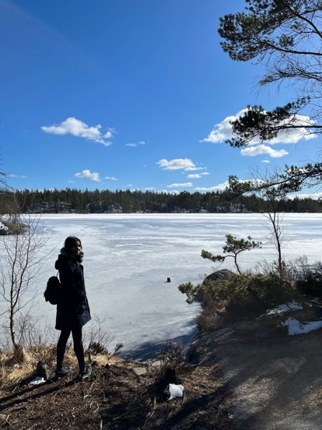
I really enjoyed my time in Sweden, which is a beautiful country full of breathtaking nature. Even in the capital Stockholm there are multiple national parks, lakes and rivers to enjoy from. I made trips to Swedish, Finish and Norwegian Lapland where I did a Husky safari, saw the Northern lights did ice swimmining while it was -15°C. I frequently hiked in the national parks around and spent a lot of time in nature. Of course, I also enjoyed the ‘Fika’, which is Swedish for a coffee break including one of their many pastries such as ‘Kanelbullar’ or ‘Semla’. I met many amazing people, both inside and outside the lab.
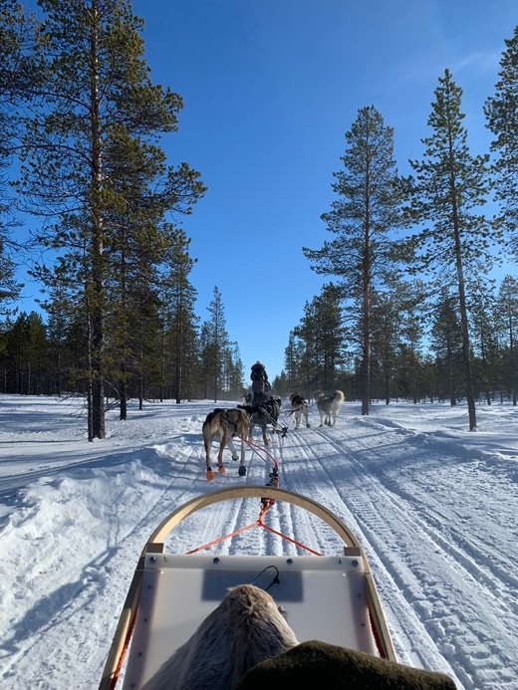
I am very grateful that NVBMB supported me in my journey abroad. I can definitely recommend it to anyone, since you will learn a lot about other (working) cultures, countries but also yourself. I think it is an amazing opportunity to develop yourself in multiple ways.
