Report of my Research Internship - at the lab van Prof. dr. Timothy Wang at the Irving Cancer Research Center/ Columbia University Medical Center, NYC, de VS.
Titel of my project: “The Development and Progression of Colon Cancer: the intestinal tuft cells as colon cancer-initiating cells”

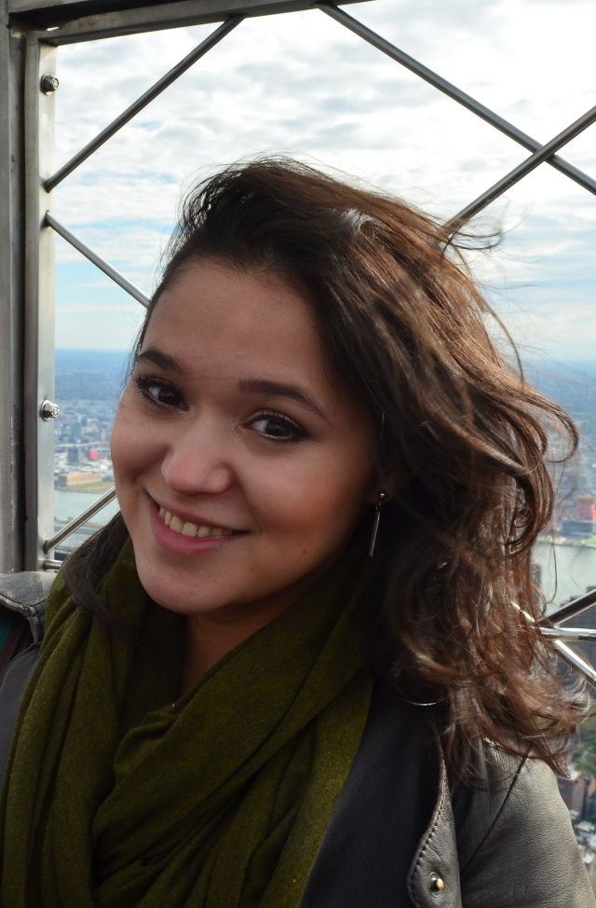
In New York I did my research internship at the lab of Prof. dr. Timothy Wang whose lab is renowned for its work on gastrointestinal malignancies, such as colon cancer. I’d done research on colon cancer before and wanted to continue in this field for my PhD, so this lab offered me the most ideal place for gaining new knowledge and experiences in this field. We worked with transgenic mouse models. These mice were carefully engineered to express certain genes in specific cell types in the colon so we could investigate which specific genes and cells were responsible for initiating colon cancer. Everybody in the lab was great, Prof. dr. Wang was a wonderful Principle Investigator and my daily supervisor was a blast. It was wonderful to be able to learn so many new lab techniques from so many talented people during my stay. Besides the fact that this lab offered me such an amazing learning experience, living in NYC was absolutely fantastic. I’ve made new friends from all over the world and got to experience NYC in the heat of summer as well as the icy cold of winter. My favorite thing to do was just to wander around the city with friends or by myself and just explore. The little place where I lived was situated in Hell’s Kitchen, a fantastic and vibrant neighbourhood with great little shops and loads of delicious food places. Often I bought my weekly groceries at the farmer’s market held in a rickety shack in a little parking lot in between old brick buildings. Well-hidden gem that little market. At the little ticket booth at Times Sq, my friends and I would get discount tickets to go see plays and musicals. The heat in the summer was insane, but it was perfect for weekends at Rockaway Beach or at Central Park. During autumn, the colors at Central Park were absolutely beautiful. The snowy cold in the winter that followed was just as crazy as the summer heat. The weather wasn’t as bad more northern places on the East Coast, but they say this winter was the second worst one in NYC’s recent history. Sometimes the snow would be so ridiculous as you would try to trudge to a store or the subway (which somehow almost always kept running). Most times, the sky would be clear and the sun strikingly bright, but crazy icy freezing winds would try to knock you down. I learned very fast from my friends that thermal undershirts and snow boots were the way to go. It was fantastic. Getting a tiny Christmas tree to my place with the subway was one of my best memories. Snow-covered NYC is beautiful. And the holidays such as Halloween (pumpkin carving!), Thanksgiving and Christmas (my parents and a friend came to visit) were fantastic. This internship was an absolutely brilliant experience. It not only taught me so many new exciting things as a researcher, but also as a person because living in NYC was phenomenal.

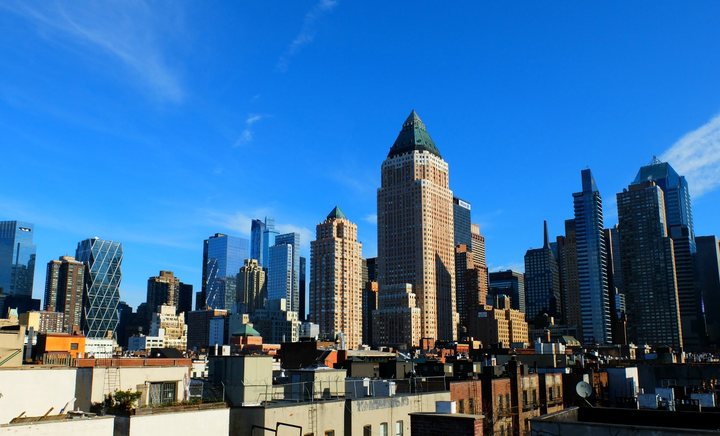
The view from the rooftop of my building

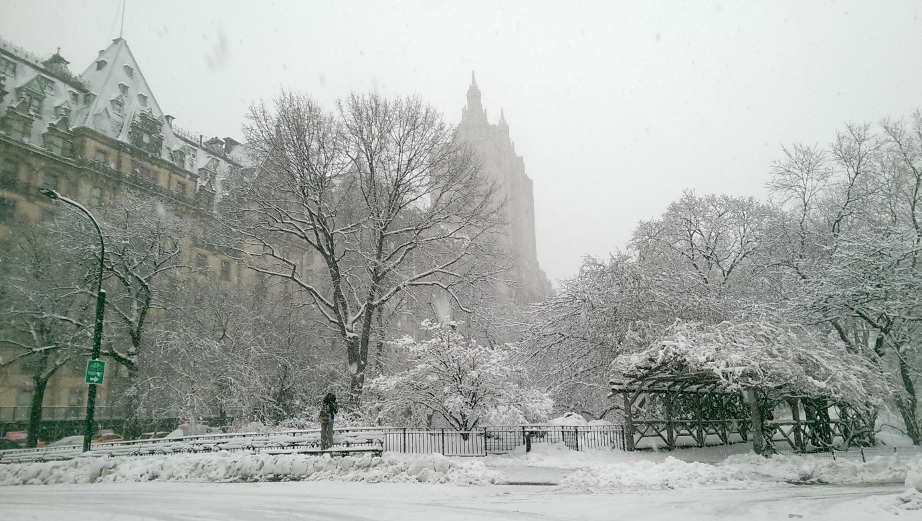
Central Park
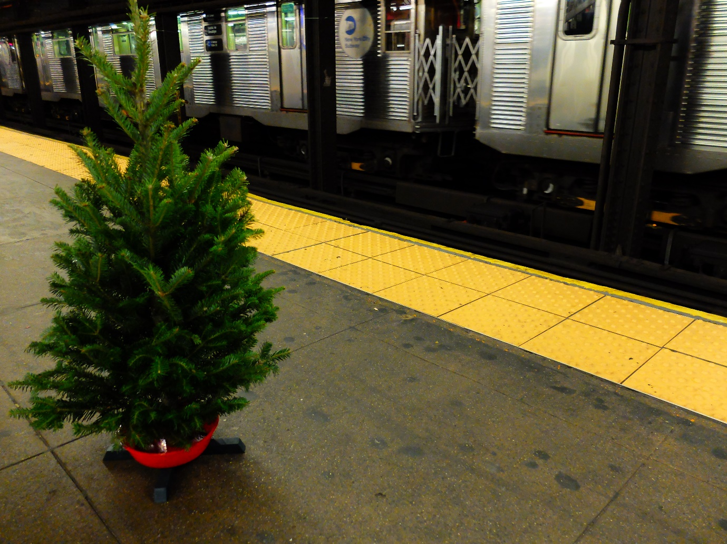
Getting my small Christmas tree with me on the subway

