From November 2022 to July 2023, I completed an internship at Karolinska Institutet in Stockholm Sweden. My project involved the characterization of critical host cell responses in alphavirus infection, in particular, Chikungunya virus. Despite not being a well-known virus, an increasing number of outbreaks have been reported in recent years, however, most concerning of all is the fact that no vaccination nor specific therapy exists for Chikungunya or any other Alphavirus. My experience in the McInerney Group was amazing, being a virology lab it was fascinating to be surrounded by researchers studying many different viruses from Coronaviruses to Alphaviruses including Ross River virus, Semliki Forest Virus and Chikungunya virus. During my time here I learnt so many new laboratory techniques including viral infection, co-immunoprecipitations and molecular cloning. Overall, it was an incredibly fulfilling and educational experience.

Aside from the lab, I also explored a lot of Scandinavia in my spare time. From visiting the artic circle in January to doing a glacier hike in the Norwegian Fjords, I have had some amazing experiences during my time in Sweden. Living in Stockholm was incredible, from watching the sunset at 2.30pm in the winter and walking to work in 30cm of snow during a blizzard, to the sun almost never setting in the summertime, you really gain a new appreciation for the seasons. I have met so many wonderful people from all over the world during my time here and gained new friends for life, many of whom I have already planned to meet up with again soon!

Sadly, all these wonderful experiences come at a price and Stockholm is not the cheapest city to live in, therefore I was incredibly grateful for the support the Nora Baart Foundation throughout my internship abroad. While my masters may now be over, I am looking forward to the next adventure and seeing where my career in science takes me!
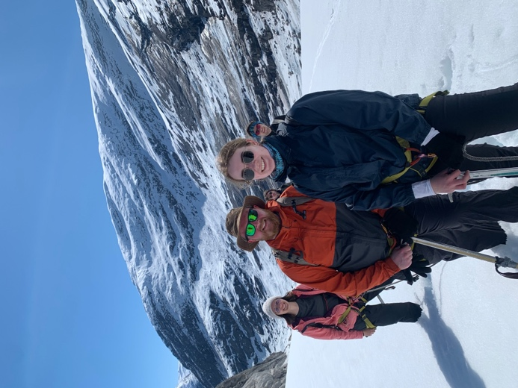
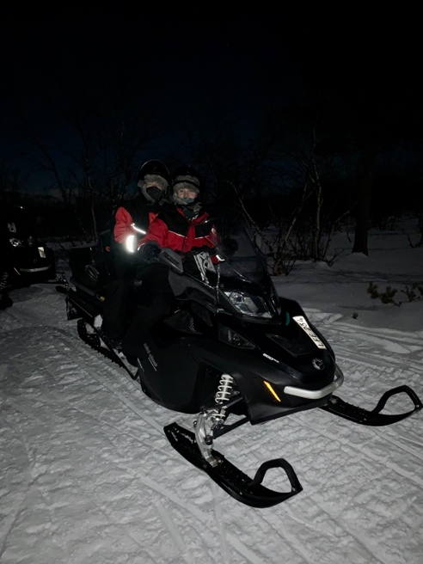
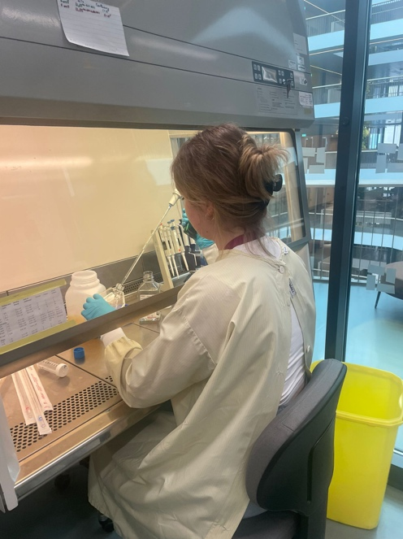
Glacier Hike in the Norwegian Fjords
Northern Lights hunting in the Artic Circle

